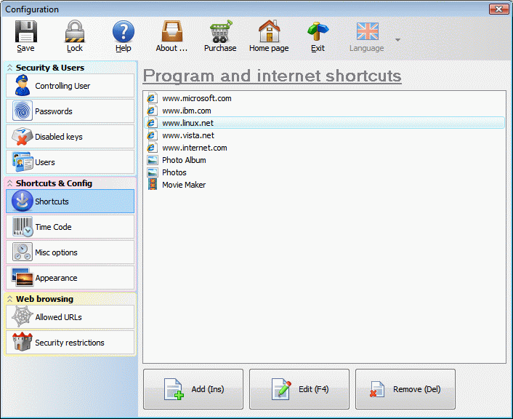

<http://www.pc-safety.com/bpppcscreenshots.html>

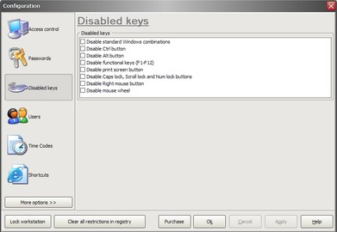

<https://public-pc-desktop.en.uptodown.com/windows>

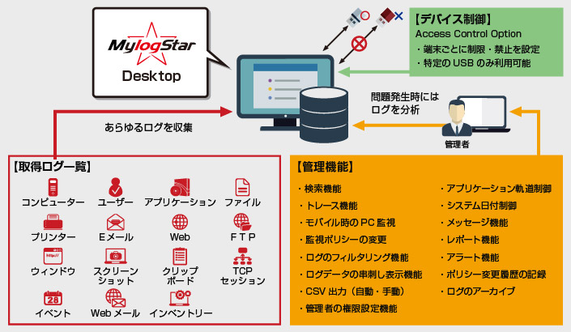

<https://www.mylogstar.net/functions>

오피스세이퍼

<https://www.officesafer.com/>